Data warehousing discussion

Name of student

Name of professor

University

Course

Date

**Components of a data warehouse**

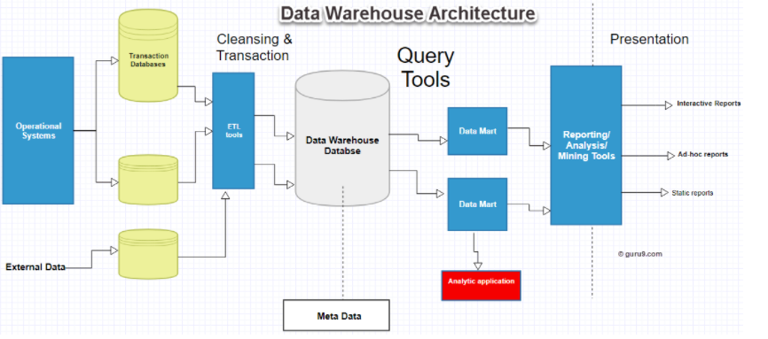

A data warehouse is considered as the single source of truth for an organizations data sources Immon (1995).

The components include:

1. The data warehouse database

Which includes all the organizations data within

1. The metadata

Is basically data of data?

1. Query tools

These are database querying tools

In order to support the business intelligence requirements of implementation, the teams needs to be versed in the following areas:

1. To understand the requirements of the business in solving the specific business problems, like what data is needed to solve a particular problem
2. To have the necessary skills / workforce that are needed to implement this particular activity, these can include, data engineers, data analysts and software engineers
3. To have the necessary data infrastructure and tools such as servers and storage spaces
4. Finally a s project execution plan

References

Inmon, W. H. (1995). What is a data warehouse. *Prism Tech Topic*, *1*(1), 1-5.

Gardner, S. R. (1998). Building the data warehouse. *Communications of the ACM*, *41*(9), 52-60.

Vaisman, A., & Zimányi, E. (2014). Data warehouse systems. *Data-Centric Systems and Applications*.